Class – Chaffinches Term 3
 | Term | Theme | English | English  -SPAG | Maths | Science | Geography | PE
 | 3 | 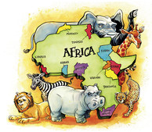  Africa (Significant Person: David Attenborough)  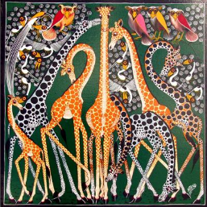 | Persuasion- advert for recyclable  Persuasive letter  Poetry  Handa’s surprise  Persuasive pitch (Dragons Den)  Non-chronological report on an aspect of Africa | Full-stops and capital letters  Using !/?  Subordinate clauses  Expanded noun phrases  Homophones  Figurative language | White Rose Maths  Year 2  Multiplication and Division  Statistics  Year 3  Multiplication and Division  Money  Statistics | Living things and habitats  - describe how animals obtain their food from plants and other animals, using the idea of a simple food chain, and identify and name different sources of food.  Light  - recognise that they need light in order to see things and that dark is the absence of light  - notice that light is reflected from surfaces  - recognise that light from the sun can be dangerous and that there are ways to protect their eyes  - recognise that shadows are formed when the light from a light source is blocked by a solid object  - find patterns in the way that the size of shadows change. | Locating Africa  The necessity of water  Human and physical features of Africa  Food and fair trade  Recyclable Olympic  Carrying water | Attacking and defending (Netball) Hand eye co-ordination  African dance to music  Using a range of movement
 |  |  | D & T | Art | ICT | PSHE | RE | Music
 |  |  | Recyclable Olympics | Adrinka printing on to fabric  African art work in style of Gagonka | Robot algorithms | Dreams and goals | Sikhism: Prayers and worship  What is the best way for a Sikh to show commitment to God? | Exploring pentatonic scales

