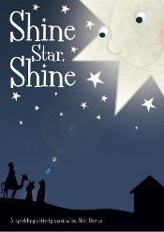
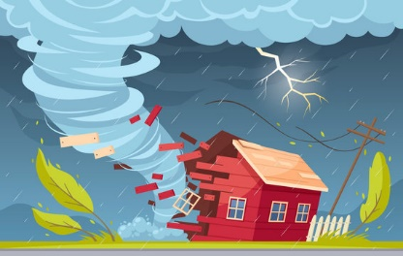
Urchfont CE Primary School

Class – Chaffinches Focus – Geography

 | Theme | English | English  -SPAG | Maths |  | Science |  | Geography |  | PE
 | Why does the earth shake? | Non-chronological report- Extreme weather  Suspense story- escaping the storm  Persuasive writing- environmental issues  Personification poetry  Reading- retrieval  Drama- participate in the Nativity | Writing in the past tense  Use question marks and exclamation marks  Develop a neat, cursive style of handwriting  Adding suffixes and the associated spelling rules  Continue to learn the spelling rules taught at Y2 and Y2 spelling list | Addition and subtraction- adding two 2 digit numbers, crossing 10, mixed addition and subtraction, problem solving, missing numbers.  Shape-  2D and 3D shapes  Properties of shapes  Symmetry |  | Weather and seasons  Observe changes across the 4 seasons  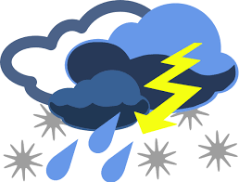  Observe and describe weather associated with the seasons and how day length varies |  | Research volcanoes and earthquakes and learn how the physical geography of our planet causes such  events to occur  Weather and climate  Natural disasters  Tectonic plates  Volcanos  Case study – the Boxing Day Tsunami |  | Forest School  PH Sports- Alternative Sports  Yoga- balance and stretching
 |  | Art / DT | ICT |  | PSHE |  | RE |  | History
 |  | Textured painting- volcanic eruption  Make papier mache volcanos to erupt. | Stop frame animation |  | Celebrating difference  Friendships  Anti-bullying |  | Christianity (Incarnation)  Has Christmas lost it’s true meaning?  The Nativity |  | Historical disasters- Mount Vesuvius and Pompeii  Significant weather events in British history

