Urchfont CE Primary School

Class – Chaffinches Whole School Focus – History

 | Term | Topic | English | English  -SPAG |  | Maths |  | Science |  | Geography |  | PE
 | 1 | Ancient Egyptians  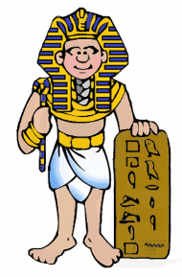 | Describing Egyptian setting  Mummification instructions  Howard Carter Diary | Focus on punctuating sentences correctly.  Learning to use the full range of punctuation including full-stops, capital letters, question marks and exclamation marks.  Building sentences using co-ordinating conjunctions e.g. and, or, but.  Expressing time and cause using conjunctions and prepositions. |  | Recognising the place value of numbers.  Securing fluency in addition and subtraction facts.  Recognising repeated addition as multiplication.  Counting in 2s, 3s, 5s and 10s.  Describing the properties of 2D and 3D shapes.  Telling the time to the hour, half hour and quarter of an hour.  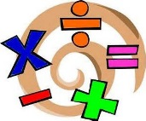 |  | Plants  Learn about the four main parts of a plant - leaves, flower, stem and roots. Understand that the roots anchor the plant in the soil and draw up water and nutrients. Know that the stem supports the plant and allows water and nutrients to travel upward. Learn that the leaves of the plant help the plant to make its own food through photosynthesis. Label a diagram of a plant and describe the functions of its 4 main parts. |  | Identify significant landmarks and cultural features of Egypt e.g The Pyramids, The Valley of the Kings  Describe the Egyptian landscape and how it has changed over time.  Discuss similarities and differences of the human and physical geography between Cairo and London.  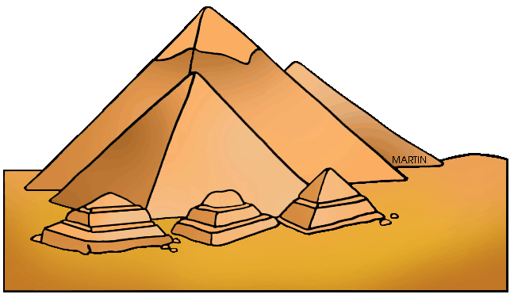 |  | Dance  Perform dances using simple movement patterns  Mr Herring- Hockey  Develop hand-eye co-ordination in order to maintain control of the ball
 |  |  | Art |  | ICT |  | PSHE |  | RE |  | History
 |  |  | Manipulate and join clay for a purpose- Canopic Jar  Understand the basic use of a sketch book and work out ideas for drawing/record visual information from different sources |  | Use and combine a variety of software (including internet services) to design and create a range of programs and content that accomplish given goals, including collecting, evaluating and presenting information.  Use technology safely, respectfully and responsibly; recognise unacceptable behaviour. |  | Dreams and Goals  Explore situations where people are faced with challenges and identify how they overcome these.  Understand that dreams and ambitions that are important.  Taking on new challenges.  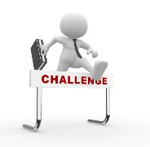 |  | Does praying at regular intervals help a Muslim in his / her everyday life? |  | Observe Egyptian books, pictures, stories and artefacts.  Develop understanding of chronology by creating a timeline of historical events.  Describe the culture, leisure activities, buildings and way of life in ancient Egypt.  Use sources and evidence to describe why people in the past acted the way they did e.g mummification.

