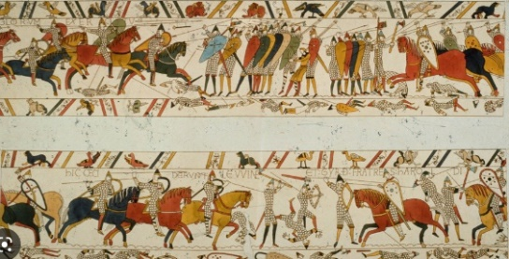
Class - WOODPECKERS Term 3 1066

English (Writing) | English  (SPAG) | Maths |  | Science |  | History
Non-Chronological report  The Battle of Hastings.  Information leaflet about Old Sarum Castle | Paragraphs  Building more complex sentences  Present perfect tense  Apostrophes for possession  Expanded noun phrases  Fronted adverbials  Formal writing  Coordinating and subordinating conjunctions | Multiplication and division  Multiply and divide by 2, 3, 4, 5, and 8  Year 4 – Multiply and divide by 3, 6, 7, 9, 11 and 12. Multiply and divide by 1 and 0.  Length and perimeter  Daily for all  Times Table Rock Star practise |  | Properties and Changes in Materials.  - To compare and group together everyday materials on the basis of their properties.  - To give reasons, based on evidence, for the particular use of everyday materials.  - Investigate the best electrical conductors.  - To know that some materials will dissolve into a solution.  - Decide how mixtures might be separated.  - To investigate irreversible changes. |  | - the Viking and Anglo-Saxon struggle for the Kingdom of England to the time of Edward the Confessor  - Anglo-Saxon laws and justice  - Edward the Confessor and his death in 1066  - The rule of William the Conqueror
Art / D & T | Spanish | ICT | PSHE |  | RE | PE
D & T  Recreate the Bayeaux Tapestry. | Eso, ¿qué es?  Saying the names of 6 pets  Saying it is or isn't a certain pet  Describing the pets with some colours  Describing pets with more colours and joining descriptions with a conjunction  Creating strange animals and describing them | Sequence in music  Introduction to Scratch  Programming sprites  Sequences  Ordering commands  Looking good  Making an instrument | Dreams and Goals  Dreams and Goals  My Dreams and Ambitions  A new Challenge  Celebrating my Learning |  | Hinduism  How can Brahman be everywhere and in everything?  The Hindu believe that there is one God with many different aspects. | Alternative sports – PH Sports  use running, jumping, throwing and catching in isolation and in combination  Forest School
 |  |  |  |  |  | Music
The children explore the pentatonic scale and ways of notating pitch. They listen to traditional Chinese music, sing, read and compose music, ending in a musical celebration of Chinese New Year.
The children develop their understanding of beat, metre and rhythm. They combine melodic and rhythmic patterns, and use staff notation as part of a final performance.
