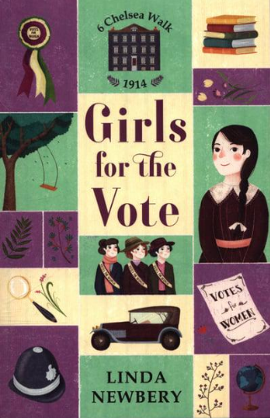
This term our class book will be Girls for the vote by Linda Newbery.

Discover the extraordinary lives of the inspiring girls who have lived throughout history at 6 Chelsea Walk.

Polly longs to become an explorer. But in 1914, women's rights and choices are limited - something twelve-year-old Polly learns when she befriends her new neighbours: two suffragettes, fighting for women's rights to vote.
Polly's parents are appalled, but Polly is intrigued. And the more she thinks about their cause, the more determined she becomes to join the suffragettes' protest march. But will Polly dare to defy her parents and do what she thinks is right?
A gripping story of courage, friendship and speaking up during a time of change, from Carnegie-shortlisted author, Linda Newbery.

