Urchfont CE Primary School Pupil premium strategy statement

This statement details our school’s use of pupil premium (and recovery premium for the 2021 to 2022 academic year) funding to help improve the attainment of our disadvantaged pupils.

It outlines our pupil premium strategy, how we intend to spend the funding in this academic year and the effect that last year’s spending of pupil premium had within our school.

School overview
Detail | Data
School name | Urchfont CE Primary
Number of pupils in school | 96 (Sept 2021)
Proportion (%) of pupil premium eligible pupils | 16.7% -Sept 2021  8.3% - FSM  0.01% - FSM6  6.4% - Service  0.01% - Adoption  0 - LAC  0 - EAL
Academic year/years that our current pupil premium strategy plan covers (3 year plans are recommended) | 2021- 2024
Date this statement was published | September 2021
Date on which it will be reviewed | September 2022
Statement authorised by | Mrs Carol Talbot
Pupil premium lead | Mrs Carol Talbot
Governor / Trustee lead | Mrs Anya Watson
Funding overview
Detail | Amount
Pupil premium funding allocation this academic year | £ 19,725
Recovery premium funding allocation this academic year | £ 2000
Pupil premium funding carried forward from previous years (enter £0 if not applicable) | £0
Total budget for this academic year  If your school is an academy in a trust that pools this funding, state the amount available to your school this academic year | £21,725

Part A: Pupil premium strategy plan

Statement of intent
At Urchfont CE Primary School, we value and nurture each individual, and aim to ensure that all children reach their full potential. We recognise that our pupils in receipt of Pupil Premium might face particular barriers in reaching their potential and might at times, feel that their experiences do not follow the overwhelming culture of other children. Therefore, at Urchfont, we are determined and committed to provide the necessary support and opportunities that these pupils require to overcome them. We will provide opportunities to raise the aspirations of these pupils and strive for excellence for all.
The Pupil Premium funding that the school receives will be used effectively to implement the necessary support and provision to support identified ‘disadvantaged’ pupils to facilitate pupil’s access to education, access to a rich and varied curriculum, including extra-curricular activities, and access to specific interventions, outlined within this Pupil Premium Strategy Plan. This has been informed by the latest research, guidance and regular evaluation, to meet the children’s pastoral, social and academic needs.
High-quality teaching is at the heart of our approach, with a focus on areas in which our disadvantaged pupils require the most support. This is proven to have the greatest impact on closing the disadvantage attainment gap and at the same time will benefit non-disadvantaged pupils in our school. Implicit in our intended outcomes is the intention that all pupils’ attainment will be sustained.
Our strategy is also integral to wider school plans for education recovery and will be responsive to the common challenges and individual needs. To ensure they are effective we will: -
- Ensure disadvantaged pupils are challenged in the work they are set
- Act early to intervene at the point need is identified
- Adopt a whole school approach in which all staff take responsibility for disadvantaged pupils’ outcomes and raise expectations of what they can achieve

Challenges

This details the key challenges to achievement that we have identified among our disadvantaged pupils.
Challenge number | Detail of challenge
1 | Risk of disadvantaged pupils making less than expected progress with their peers with similar starting points
2 | Disadvantaged pupils with SEND needs make even less progress than non – disadvantaged pupils with SEND
3 | Disadvantaged pupils are more likely to live in a home with one parent who has health issues
4 | Parental engagement to promote positive attitudes towards learning might be less than non –disadvantaged pupils
5 | Emotional vulnerability of pupils in receipt of pupil premium
6 | Additional costs limits access to extra-curricular opportunities e.g. clubs, music tuition etc
7 | Negative impact of COVID-19, including lack of support and ICT

Intended outcomes
This explains the outcomes we are aiming for by the end of our current strategy plan, and how we will measure whether they have been achieved.
 | Intended outcome | Success criteria
1 | Disadvantage pupils achieve in line with their peers with similar starting points | 80%+ make expected or better progress than expected progress in reading, writing and mathematics
2 | Disadvantage pupils with SEND achieve in line with their peers with similar starting points | Disadvantaged pupils with SEND make expected progress in reading, writing and mathematics
3 | Parents are actively engaged in their child’s education and promote a positive attitude to education | Parental communication is effective, especially during home learning period s with both children and parents accessing the Google Classroom for learning and meeting up with class teacher and peers.  Parents attend parents evening either via the School Cloud or by telephone.  Parents support home learning.  Pupils attendance is in line with peers.
4 | Pupils’ emotional and mental health needs are met and receive the necessary support when required. | All pupils feel safe and happy at school, maintaining a positive attitude towards their learning and build positive relationships with their peers and staff members.
5 | All pupils have access and equal opportunities to participate in extra- curricular activity. | Disadvantage pupils are able to participate in chosen extra- curricular activities.
6 | Disadvantaged pupils have access to the necessary IT equipment, internet and /or resources to carry out home learning | Pupils carry out home learning successfully and submit work each day/week during any periods of enforced isolation.

Activity in this academic year
This details how we intend to spend our pupil premium (and recovery premium funding) this academic year to address the challenges listed above.

Teaching (for example, CPD, recruitment and retention)
Budgeted cost: £ 7842
Activity | Evidence that supports this approach | Challenge number(s) addressed
Use of TAs to provide targeted intervention for pupils whose prior attainment indicates the need for them to make accelerated progress to reach appropriate ARE | Sutton Trust (2011) report revealed that the effects of high quality teaching are especially significant for pupils from disadvantaged backgrounds. This has been successful in the past. Use of intervention plans ensure that children make good progress in reading, writing and maths. Use of TAs enabled higher ratios within classes to support teaching and learning. | 1, 2
Use of Nessie within the EYFS / Year 1 class | The average impact of Oral language interventions is approximately an additional six months’ progress over the course of a year. Some studies also often report improved classroom climate and fewer behavioural issues following work on oral language.  Approaches that focus on speaking, listening and a combination of the two all show positive impacts on attainment. | 1, 2
Use of Times Table Rock Stars | Effective use of TTRS in other schools.  EEF research suggests that appropriate homework tasks can increase progress by up to 5 months. | 1, 2

Targeted academic support (for example, tutoring, one-to-one support structured interventions)
Budgeted cost: £ 6429
Activity | Evidence that supports this approach | Challenge number(s) addressed
1-to-1 TA led SALT intervention based on Speech therapist targets following periodic reviews | EEF research focused on teaching assistants who provided one to one or small group targeted interventions. It shows a positive benefit of between four and six additional months on average. This is best when the interventions are based on a clearly specified approach which teaching assistants have been trained to deliver which is evident with this intervention. | 2
1-to-1 and small group TA led provision based on teacher directed activities following half-termly reviews | EEF research focused on teaching assistants who provided one to one or small group targeted interventions. It shows a positive benefit of between four and six additional months on average. | 1, 2
Teacher led reading comprehension strategies with pupils grouped in small groups. | EEF research suggests the average impact of reading comprehension strategies is an additional six months’ progress over the course of a year. Successful reading comprehension approaches allow activities to be carefully tailored to pupils’ reading capabilities, and involve activities and texts that provide an effective, but not overwhelming, challenge. | 1,2
Teacher led writing strategies with pupils grouped in small groups, including collaborative approaches | EEF research suggests the impact of collaborative approaches on learning is consistently positive, with pupils making an additional 5 months’ progress, on average, over the course of an academic year | 1, 2

Wider strategies (for example, related to attendance, behaviour, wellbeing)
Budgeted cost: £7227
Activity | Evidence that supports this approach | Challenge number(s) addressed
No charge for disadvantaged pupils to access extra-curricular activities such as after-school clubs, educational day visits, music tuition | EEF research indicates improved outcomes have been identified in English, Mathematics and Science learning. On average, greater effect has been identified for younger learners. Widespread evidence on positive impact on self -esteem | 4. 5,
Ensure pupils have access to a trained Emotional Literacy Support Assistant (ELSA). Termly needs audit by ELSA and class teachers to assess unmet mental health needs. | Research (See study by Bowerman & Davies, Child and Educational Psychologists ) suggest positive outcomes for LAC children in relation to access to ELSA. | 4
Provide access to school’s Parent Support Advisor who can provide support and advice, family signposting to parental course and supporting families to access charities where necessary eg local foodbank, clothing charity | EEF research indicates the average impact of the Parental engagement approaches is about an additional four months’ progress over the course of a year. There are also higher impacts for pupils with low prior attainment. | 3, 4
Ensure pupils are dressed in similar clothing to their peers by school purchasing school sweatshirts on their behalf – this ensures positive self -esteem within the pupils. | Although the EEF research stated that the lack of studies could not identify that a school uniform approach increased the progress for individual pupils, there is a belief in some countries that school uniform supports the development of a whole school ethos and therefore supports discipline and motivation. Some also believe that a uniform promotes social equity. | 4
Deploy appropriate IT equipment and resources for pupils who are required to undertake home learning for a period of time. | DFE’s Remote Education expectation state that the remote education provided should be equivalent in length to the core teaching pupils would receive in school.  The school uses Google Classroom as their virtual learning platform. When appropriate, school is able to provide appropriate tablets to access the Google Classroom. | 6

Total budgeted cost: £ 21,501

Part B: Review of outcomes in the previous academic year

Pupil premium strategy outcomes
This details the impact that our pupil premium activity had on pupils in the 2020 to 2021 academic year.
Impact of Teaching and Targeted Academic Support
Because of the national lockdown 5/01/21 – 8/03/21, many disadvantaged children remained at home, even though they were eligible to come to school. This was despite encouragement from school including contact from class teachers and head teacher. Attendance. Seven out of the fifteen pupils attended in some capacity, at least on a part-time basis, which is 47%. School offered, all of those remaining at home, a digital device – 1 child took up this offer – 12.5%
Internal Assessments – Summer 2021
Reading

Pupil Premium/ Disadvantaged
Below expected Progress | 2/15 | 13%
Expected progress or better | 13/15 | 87%
Above expected progress | 4/15 | 27%

Writing
Pupil Premium/ Disadvantaged
Below expected Progress | 6/15 | 40%
Expected progress or better | 9/15 | 60%
Above expected progress | 4/15 | 27%

Maths
Pupil Premium/ Disadvantaged
Below expected Progress | 4/15 | 27%
Expected progress or better | 11/15 | 73%
Above expected progress | 5/15 | 33%

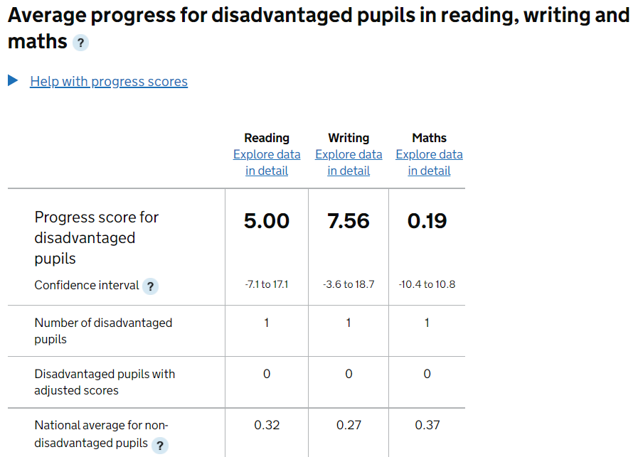
2019 National Assessments

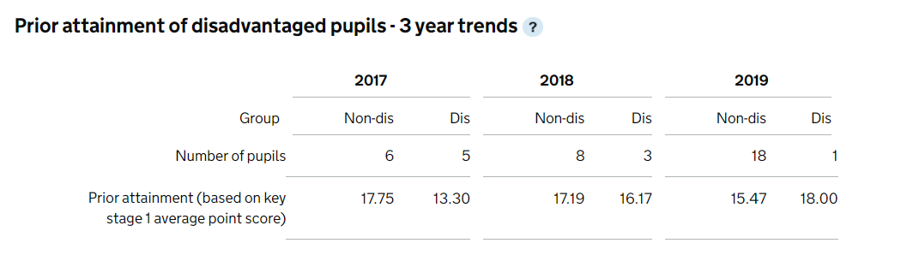
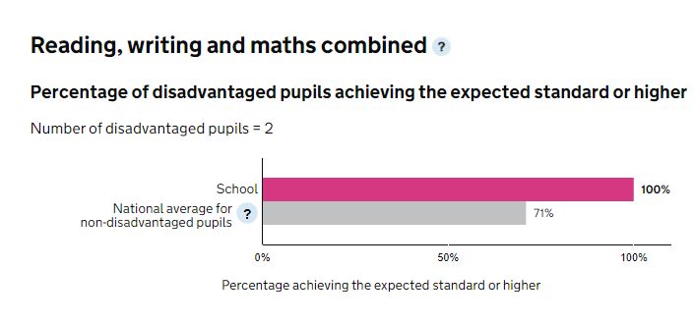
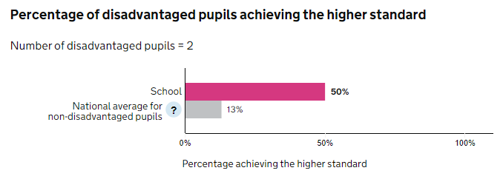

Externally provided programmes
Programme | Provider
White Rose Maths | School
Nuffield Early Language Intervention | School
The Oracy Project | WCC
Little Wandle’s Letter & Sounds | School

Service pupil premium funding
Measure | Details
How did you spend your service pupil premium allocation last academic year? | There were 4 children in receipt of service pupil premium funding in the last academic year.  Strategies funded by this allocation including SALT intervention with a TA, ELSA support and funding extra- curricular activities including music tuition.
What was the impact of that spending on service pupil premium eligible pupils? | All pupils are non-mobile and have attended the school for many years. When required they have access to intervention available to all.  75% of pupils are achieving at expected or greater than expected than their peers.

