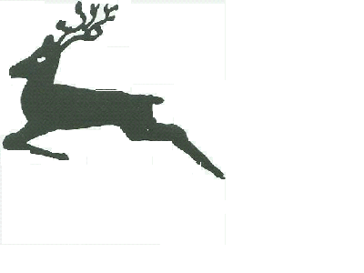
Urchfont C. E. Primary School
Cuckoo Corner, Urchfont, Devizes, Wiltshire, SN10 4RA
Tel: 01380 840793
Email: admin@urchfont.wilts.sch.uk

20th May 2020

Dear Parents,

Half term is rapidly approaching and we wanted to write to update you following the Government’s announcement that there would be wider opening of schools to pupils from 1 June 2020.

As you will be aware, pending the meeting of the the five key tests set by government, from 1 June 2020 primary schools are being asked to welcome back children in Reception, Year 1 and Year 6 as well as continuing to be open for the children of key workers and vulnerable children.

Following the guidance received from both the Department for Education and Wiltshire Council, we have been working on our plan to implement the approaches set out in preparation for reopening on 1 June 2020.

We have surveyed parents on whether they would send their child back to school and I thank those who have completed this for us. To ensure that we can complete our plans, we need to know how many key worker children in Years 2,3,4 & 5 will be attending school. Places will be limited due to the social distancing rules and we will need to prioritise children. Therefore, if you believe you are a key worker and you want your child to attend school, the first week of term 6, please use the booking system or email admin@urchfont.wilts.sch.uk by Sunday 24th May at the latest. If we do not hear from you, we will assume that your child will not be attending the week after half term.

For following weeks, we will need to be informed one working week (5 working days) in advance for key worker children as we may need to cap these numbers because of staffing numbers.

Yours sincerely

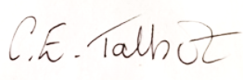
Mrs CE Talbot
Head Teacher

