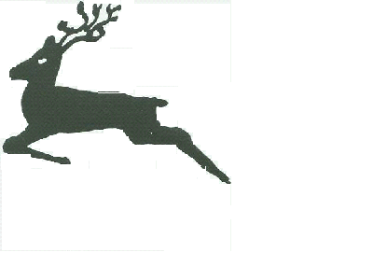
Urchfont C. E. Primary School
Cuckoo Corner, Urchfont, Devizes, Wiltshire, SN10 4RA
Tel: 01380 840793
Email: admin@urchfont.wilts.sch.uk

22nd May 2020

Dear Parents/Guardians,

We have been really busy over the past couple of weeks trying to plan the safest way to welcome Years R, 1 & 6 back to school, along with critical worker and vulnerable children. To the parents of children eligible to return to school, thank you for indicating whether your child will be returning. This has helped us to plan how we will manage this return, and I have sent out a letter setting out the details of what school will be like.

If the government announce at the end of next week, that schools will definitely be reopening at the beginning of June, Urchfont school will reopen on Tuesday 2nd June, for Y6 children only, with any key worker and vulnerable children. We will then welcome the YR/1 children to school on Thursday 4th June. However, we are still awaiting a date for the chlorination of the water pipes. We are hoping this will take place early in the half term break. If there is a delay in this happening, to later in the half term break, we cannot open to children as the water will not be fit to drink. We will inform you via Parentpay if this is the case and of the new reopening date.

Staff have been set the challenge by the DFE to continue to provide remote learning for those who remain at home, as well as class learning for those in school. We will endeavour to continue to deliver the high quality work that has been produced over the last couple of months using the Google Classroom and will strive to find a way to continue to support those pupils who remain at home. However, staff will not be able to reply to queries with the speed that has been achieved over the last few weeks.

If your child is returning, I would appreciate if you could share with them what school will be like and how different it will be. Otherwise, it could be quite a surprise for them. Staff are considering posting photos or short clips of their classrooms on the Google Classroom so children can see how different they are. Please look out for them.

There have been suggestions that all children might return later in the term. If this happens then we might need to put other plans and measures into place and will obviously share these with you at that time. We had planned three TD days – 1st , 26th and 29th June, because of the situation we now find ourselves in, we have decided to move all three days to the end of the term and therefore school will close to children on Friday 17th July.

As I have previously said, please contact us if you have any concerns or queries and we will try to help and support you at this very difficult and unprecedented time. I wish you and your family a restful break and hope the weather is kind, and allows us all to get out in the garden and go for walks in our local area (I’m still sticking to that rule!)

Have a lovely half term and no home learning please!
With warmest regards and please continue to keep safe!
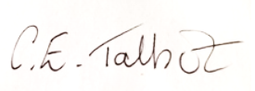

Mrs CE Talbot
Head Teacher

